

Position Description

Reporting to: Nic Brown, Principal

Agreement: Support Staff in Schools Collective Employment Agreement or IEA

Grade: To be assigned

Role specific and technical requirements

Qualifications:
- A formal qualification or equivalent experience as defined in the schedule of the Collective Employment Agreement
- A library qualification, a trained teacher qualification or a degree
- Understanding of tikanga Māori and a willingness to learn Te Reo Māori

Demonstrable knowledge/experience:
- Excellent interpersonal skills
- Previous relevant experience in paid or unpaid library work
- Understanding of library systems
- ICT skills and knowledge including Accessit Library Program

Core Competencies for staff:
- Understand and respect our Staff values/Kotahitanga
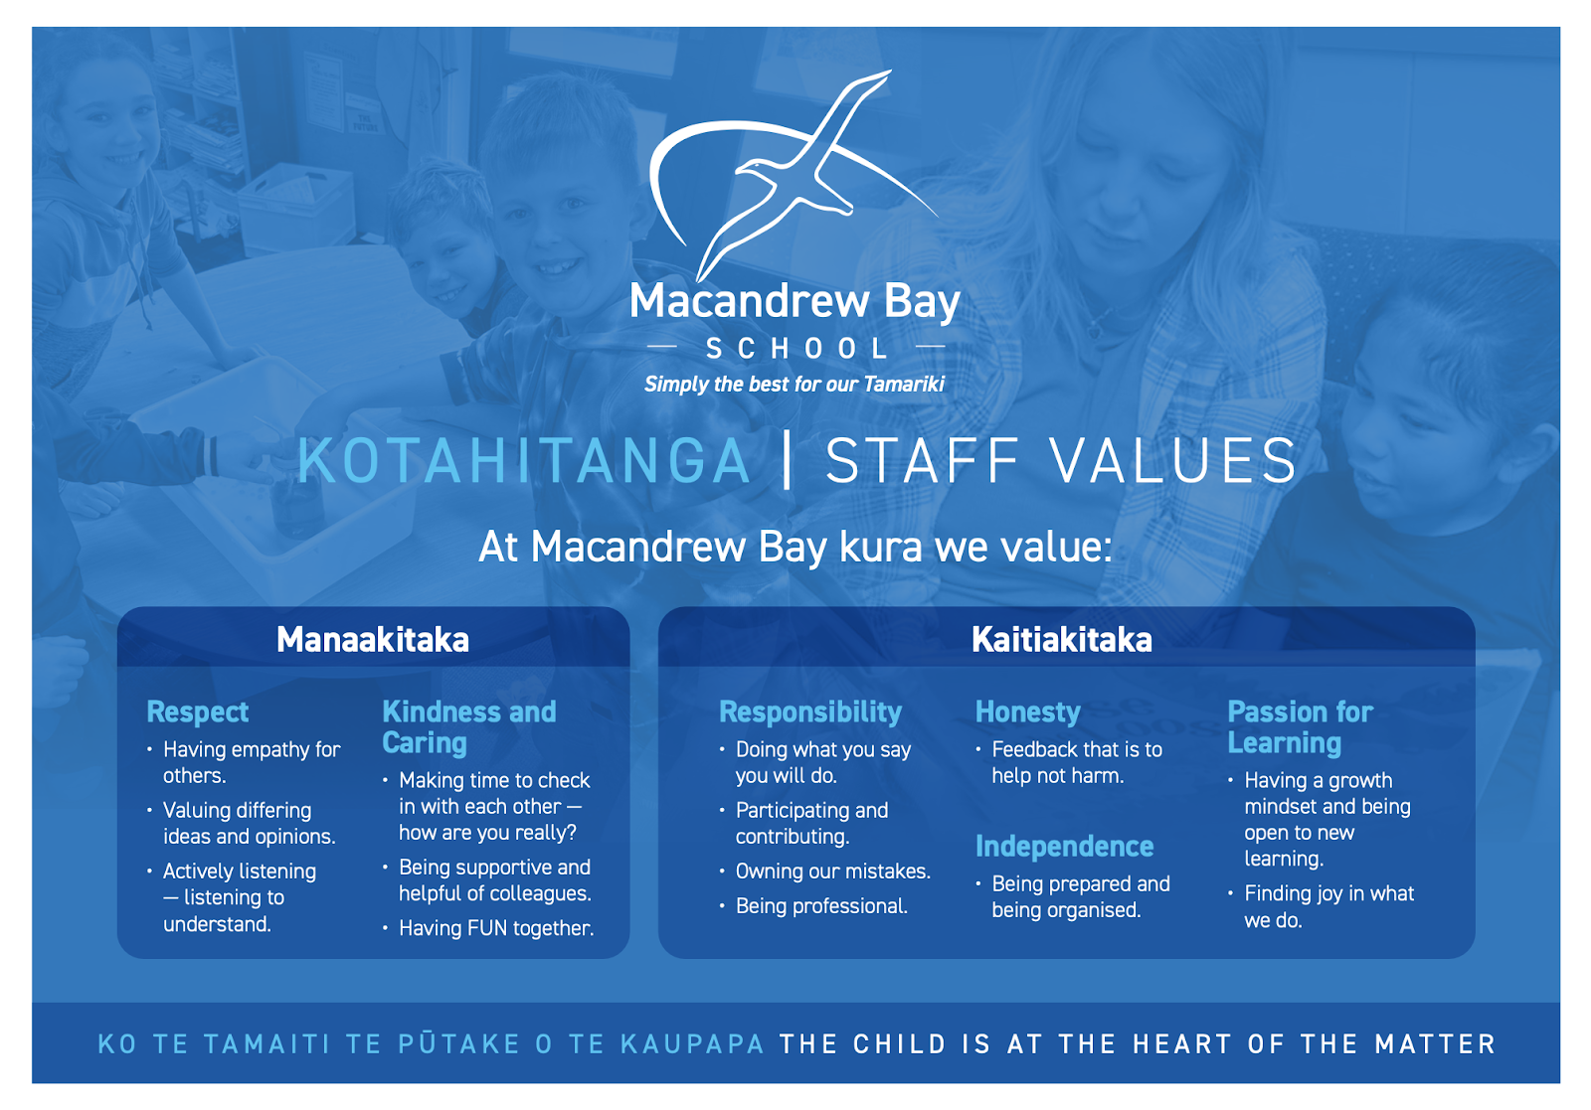

Participating and Contributing – Demonstrating the ability to respond appropriately as a group member and to make connections to others

- Supports and models the school’s values at all times
- Supports and assists students
- Understands the concept of work/life balance
- Identifies and participates in learning opportunities as appropriate for personal development
- Accepts and manages personal responses to change in a positive manner
- Works collaboratively as a team member

Thinking and Communicating – Using creative, critical and reflective processes to make sense of and question information, experiences and ideas

Verbal
- Conveys simple information clearly, logically and accurately
- Can provide directions, information and assistance about the library
- Provides information and assistance to students about ICT
- Listens and asks questions to maximise understanding
- Understands the different communication styles required when dealing with students and staff
- Actively listens to what others have to say
- Uses relevant verbal and non-verbal clues to check for understanding

Writing
- Writes in an appropriate manner so material is easily understood
- Written work is accurate
- Written reporting to BOT
- Report to auditors at the end of each school year

Problem solving
- Collects data relevant to the issue
- Completes analysis of data
- Consults/seeks assistance when necessary
- Keeps appropriate people informed during the decision making process

Management of Self – being responsible for the delivery of the work requirements and maintain ethical standards

- Accepts ownership for delivering to commitments
- Uses time productively
- Has a ‘can do’ attitude
- Establishes systems and methods for organizing resources
- Plans and organises tasks on a day-to-day basis to achieve results
- Checks for agreement and approval before acting and seeks assistance when required
- Is aware of the effects their words and attitudes have on others
- Maintains own well-being
- Continually maintains professional knowledge

Relating to Others – achieves objectives through working as part of a team, freely sharing knowledge and using others strengths

- Actively builds positive and productive working relationships
- Builds personal credibility with students
- Is approachable, open, non-defensive and transparent in dealings with others
- Shares relevant knowledge with others
- Accepts constructive criticism and learns from it
- Shares credit with others

Job Purpose

The primary purpose of this position is to support learning through the delivery of quality library resources. The Librarian will be required to build strong relationships and credibility with ākoka and kaiako/kaimahi. The Librarian will undertake to support the learning for students and to support the behaviour management in the school.

Service Delivery

Tasks | Performance Criteria
Maintain Library System | - Catalogue library resources  - Inform teachers and students about the operation of the Library system  - Maintain and update library web page
Daily Management | - Monitor the physical environment in terms of comfort, heat, light, fresh air etc  - Maintain register of library bookings  - Set up the library for specific classes  - Ensure students are advised of the safe internet procedures and that these are displayed in the library  - Issue and process returned library books  - Sort, file and shelve resources
Purchases | - Manage library budget expenditure  - Purchase library consumables  - Maintain up to date record of purchases including donations
Engagement with Students | - Assist students to define learning and information needs and to locate and use resources available  - Assist students to access and evaluate information from multiple sources in order to learn, to create and to apply new knowledge.  - Keep up to date with current research on  - Teaching and learning and apply this to student learning in the library  - Engage in encouraging and supportive  - Dialogue with students about the learning  - Discuss reading needs with teachers  - Inspire and motivate our tamariki to positively engage with the library
Instructional Partnership with Teachers | - Engages with teachers regarding Curriculum  - Working with teachers to ensure the integration of research skills in the curriculum  - Design and implement school-based in service education for teachers and out the use of library facilities and the development to research skills Recommend and order appropriate resources to supplement curriculum areas  - Act as a consultant to teachers providing ideas and materials for curriculum development
Student Librarians and Library users | - Explain library processing  - Develop skills using the library systems and research skills to locate information  - Supervise their work in issuing materials, processing returns, shelving and repairing materials  - Support behaviour issues they have with other students
Promotion | - Promote the library through displays, special events such as book week, etc  - Organise Summer Reading every Christmas holiday break
Equipment | - Maintain equipment used in the library including computers, and chromebooks  - Operate equipment in the library and repair and deal with minor faults
Tasks | - Performance Criteria
Health and Safety | - Identify and eliminate or minimise hazards in the workplace
 | - Be aware of emergency procedures
 | - Report accidents, injuries and hazards
 | - The code of practice for computer use is adhered to
 | - Workload issues are reviewed and prioritized
Volunteers | - Supervise and instruct volunteers who repair or cover books and resources  - Ensure volunteers sign the attendance register  - Ensure volunteers are briefed on the school’s health and safety procedures

Date: ________________________________

Principal: ____________________________________________

Librarian: ______________________________________

